Spring doc

Spring Tutorial

This spring tutorial provides in-depth concepts of Spring Framework with simplified examples. It was developed by Rod Johnson in 2003. Spring framework makes the easy development of JavaEE application.
It is helpful for beginners and experienced persons.

Spring Framework
Spring is a lightweight framework. It can be thought of as a framework of frameworks because it provides support to various frameworks such as Struts, Hibernate, Tapestry, EJB, JSF etc. The framework, in broader sense, can be defined as a structure where we find solution of the various technical problems.
The Spring framework comprises several modules such as IOC, AOP, DAO, Context, ORM, WEB MVC etc. We will learn these modules in next page. Let's understand the IOC and Dependency Injection first

Inversion Of Control (IOC) and Dependency Injection
These are the design patterns that are used to remove dependency from the programming code. They make the code easier to test and maintain.

Advantage of Dependency Injection
- makes the code loosely coupled so easy to maintain
- makes the code easy to test

Advantages of Spring Framework

1) Predefined Templates
Spring framework provides templates for JDBC, Hibernate, JPA etc. technologies. So there is no need to write too much code. It hides the basic steps of these technologies.

2) Loose Coupling
The Spring applications are loosely coupled because of dependency injection.

3) Easy to test
The Dependency Injection makes easier to test the application. The EJB or Struts application require server to run the application but Spring framework doesn't require server.

4) Lightweight
Spring framework is lightweight because of its POJO implementation. The Spring Framework doesn't force the programmer to inherit any class or implement any interface. That is why it is said non-invasive.

6) Powerful abstraction
It provides powerful abstraction to JavaEE specifications such as JDBC, JPA and JTA.

7) Declarative support
It provides declarative support for caching, validation, transactions and formatting.

Spring Modules
- Spring Modules
- Test
- Spring Core Container
- AOP, Aspects and Instrumentation
- Data Access / Integration
- Web
The Spring framework comprises of many modules such as core, beans, context, expression language, AOP, Aspects, Instrumentation, JDBC, ORM, OXM, JMS, Transaction, Web, Servlet, Struts etc. These modules are grouped into Test, Core Container, AOP, Aspects, Instrumentation, Data Access / Integration, Web (MVC / Remoting) as displayed in the following diagram.
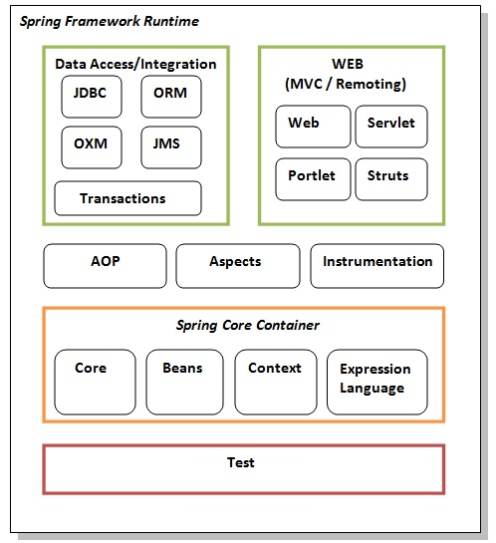

Test
This layer provides support of testing with JUnit and TestNG.

Spring Core Container
The Spring Core container contains core, beans, context and expression language (EL) modules.

Core and Beans
These modules provide IOC and Dependency Injection features.

Context
This module supports internationalization (I18N), EJB, JMS, Basic Remoting.

Expression Language
It is an extension to the EL defined in JSP. It provides support to setting and getting property values, method invocation, accessing collections and indexers, named variables, logical and arithmetic operators, retrieval of objects by name etc.

AOP, Aspects and Instrumentation
These modules support aspect oriented programming implementation where you can use Advices, Pointcuts etc. to decouple the code.
The aspects module provides support to integration with AspectJ.
The instrumentation module provides support to class instrumentation and classloader implementations.

Data Access / Integration
This group comprises of JDBC, ORM, OXM, JMS and Transaction modules. These modules basically provide support to interact with the database.

Web
This group comprises of Web, Web-Servlet, Web-Struts and Web-Portlet. These modules provide support to create web application.

IoC Container
- IoC Container
- Using BeanFactory
- Using ApplicationContext
The IoC container is responsible to instantiate, configure and assemble the objects. The IoC container gets informations from the XML file and works accordingly. The main tasks performed by IoC container are:
- to instantiate the application class
- to configure the object
- to assemble the dependencies between the objects
There are two types of IoC containers. They are:
- BeanFactory
- ApplicationContext

Difference between BeanFactory and the ApplicationContext
The org.springframework.beans.factory.BeanFactory and the org.springframework.context.ApplicationContext interfaces acts as the IoC container. The ApplicationContext interface is built on top of the BeanFactory interface. It adds some extra functionality than BeanFactory such as simple integration with Spring's AOP, message resource handling (for I18N), event propagation, application layer specific context (e.g. WebApplicationContext) for web application. So it is better to use ApplicationContext than BeanFactory.

Using BeanFactory
The XmlBeanFactory is the implementation class for the BeanFactory interface. To use the BeanFactory, we need to create the instance of XmlBeanFactory class as given below:
- Resource resource=new ClassPathResource("applicationContext.xml");
- BeanFactory factory=new XmlBeanFactory(resource);

Using ApplicationContext
The ClassPathXmlApplicationContext class is the implementation class of ApplicationContext interface. We need to instantiate the ClassPathXmlApplicationContext class to use the ApplicationContext as given below:
- ApplicationContext context =
- new ClassPathXmlApplicationContext("applicationContext.xml");
The constructor of ClassPathXmlApplicationContext class receives string, so we can pass the name of the xml file to create the instance of ApplicationContext.

Dependency Injection in Spring
Dependency Injection (DI) is a design pattern that removes the dependency from the programming code so that it can be easy to manage and test the application. Dependency Injection makes our programming code loosely coupled.

Dependency Injection
The Dependency Injection is a design pattern that removes the dependency of the programs. In such case we provide the information from the external source such as XML file. It makes our code loosely coupled and easier for testing. In such case we write the code as:
- class Employee{
- Address address;

- Employee(Address address){
- this.address=address;
- }
- public void setAddress(Address address){
- this.address=address;
- }

- }
In such case, instance of Address class is provided by external souce such as XML file either by constructor or setter method.

Two ways to perform Dependency Injection in Spring framework
Spring framework provides two ways to inject dependency
- By Constructor
- By Setter method

Upcoming topics in Spring Dependency Injection
Dependency Injection by constructor
Let's see how we can inject dependency by constructor.

Dependency Injection by setter method
Let's see how we can inject dependency by setter method.

